# Creating a Report Server Project

Open MSVS / New / Project

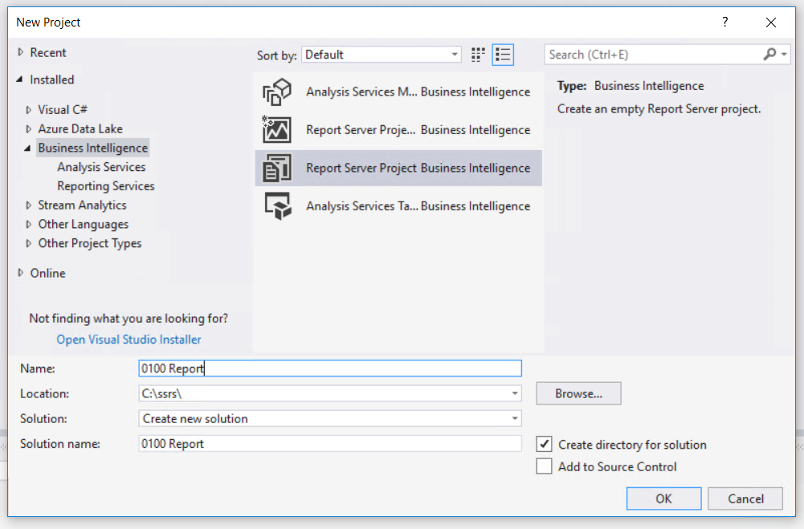

Use Windows Explorer to see project’s folder

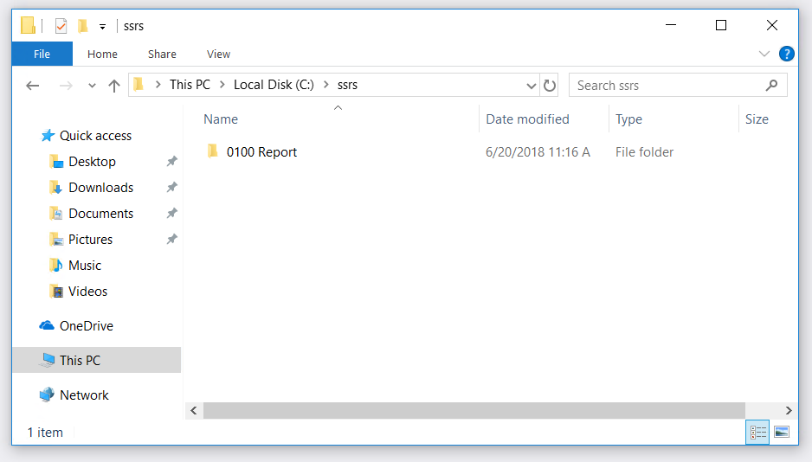

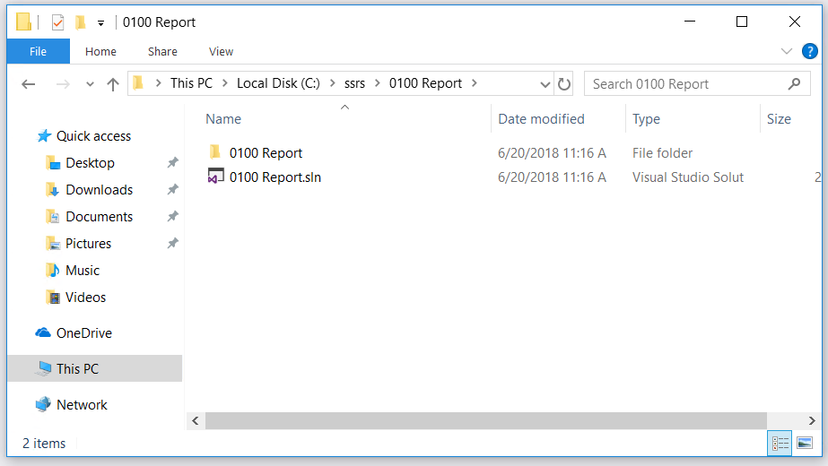

Right click at Report Icon in Solution Explorer / Add / New Item…

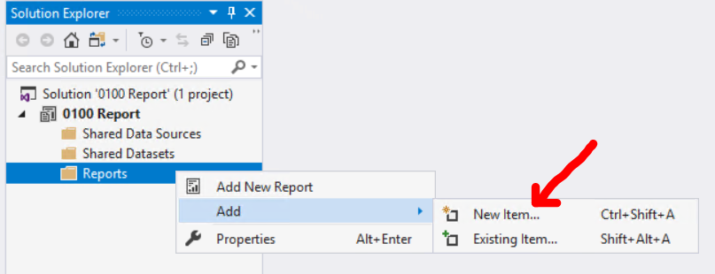

Click Report / Name = Sales Orders.rdl / Add

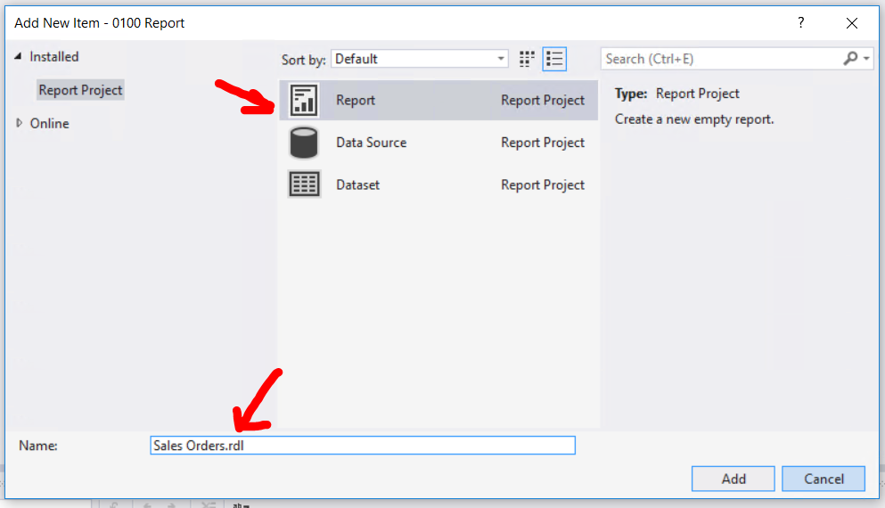

Look at Report Data / Design & Preview / Properties

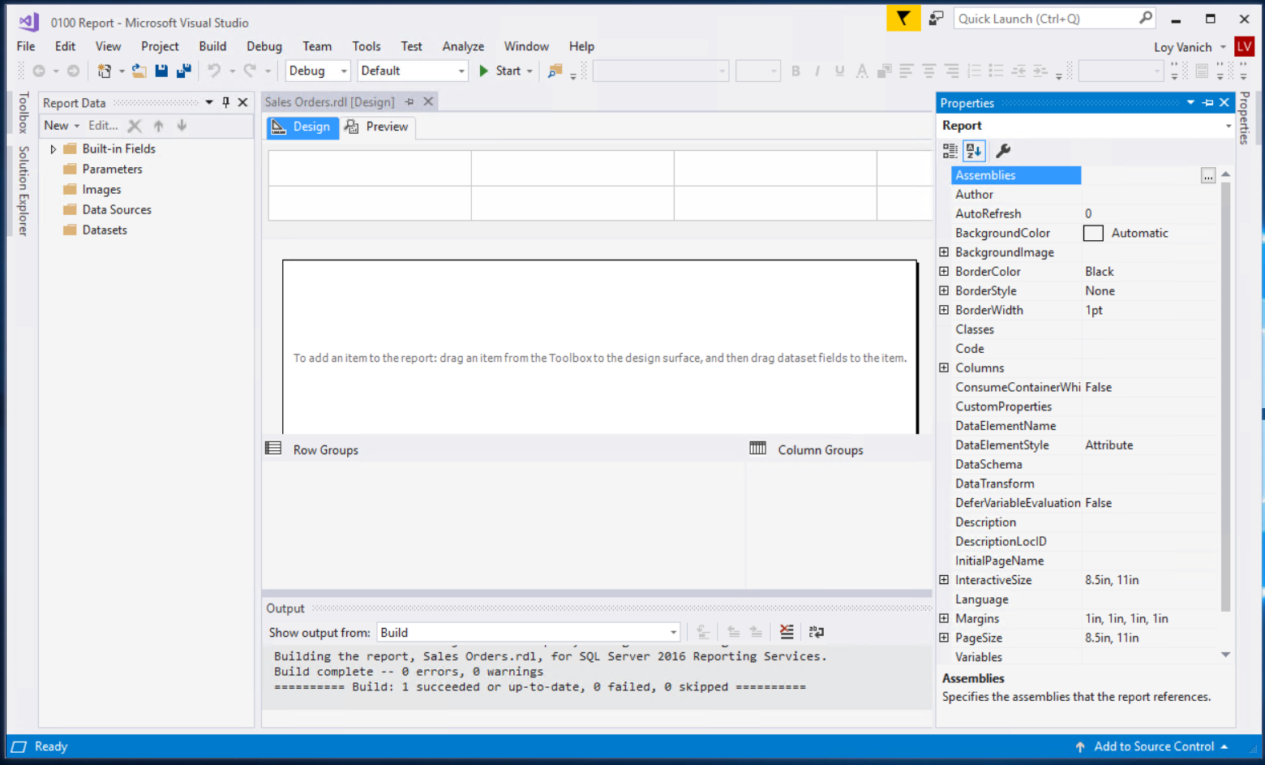

# Specifying Connection Information

Report Data / New / Data Source

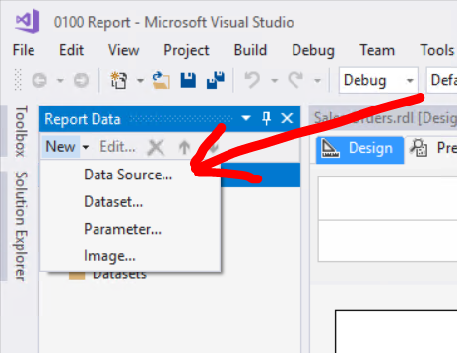

General / Name = AdventureWork2017LT / Embedded / Type = Microsoft SQL / press Edit…

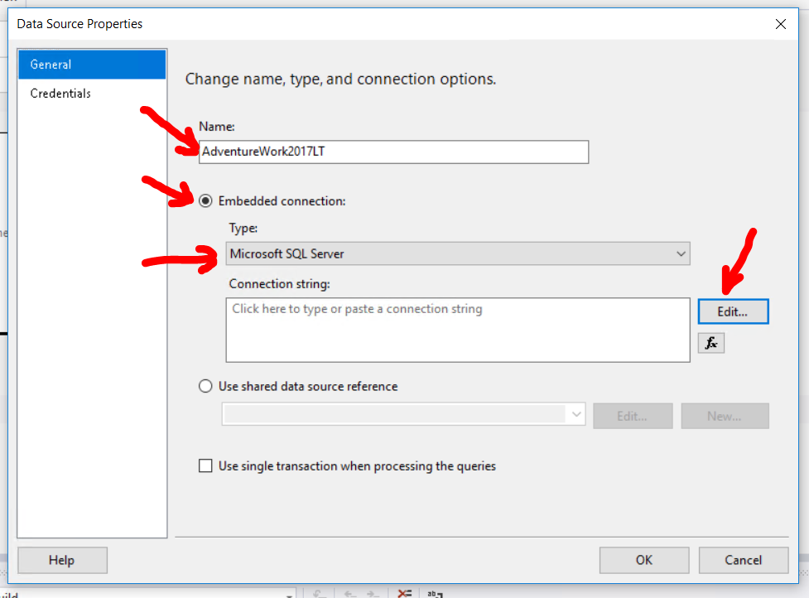

Server name / Authentication / Select database / Test Connection / OK / OK

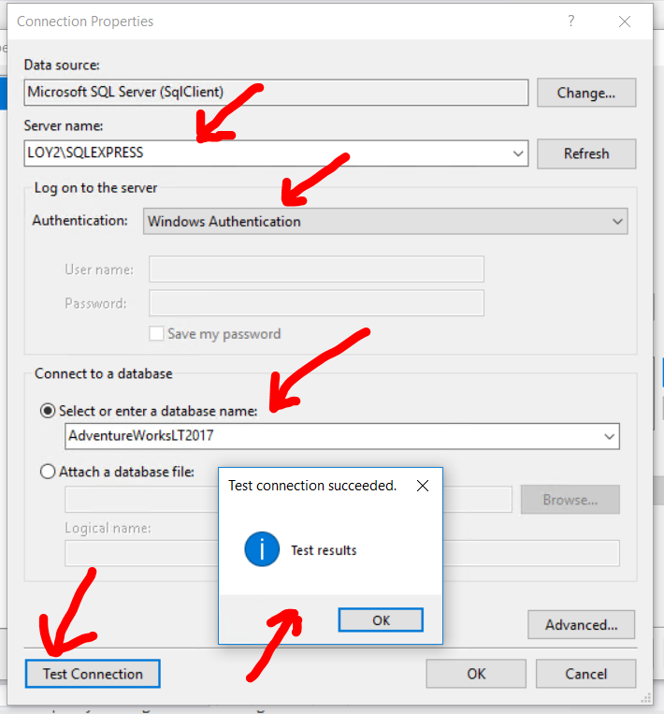

Look at Report data / Data Sources. Make sure u have AdventureWork2017LT

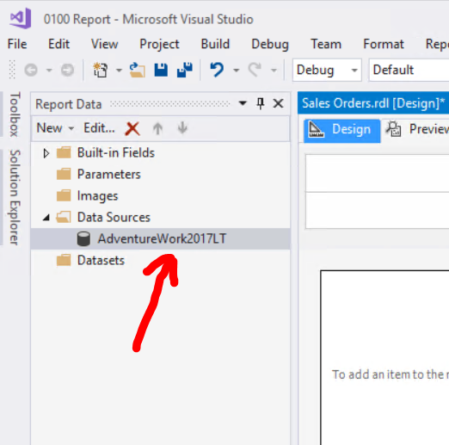

# Defining a Dataset for the Table Report

Click Table icon in Toolbox / Click Design surface and drag to draw a table

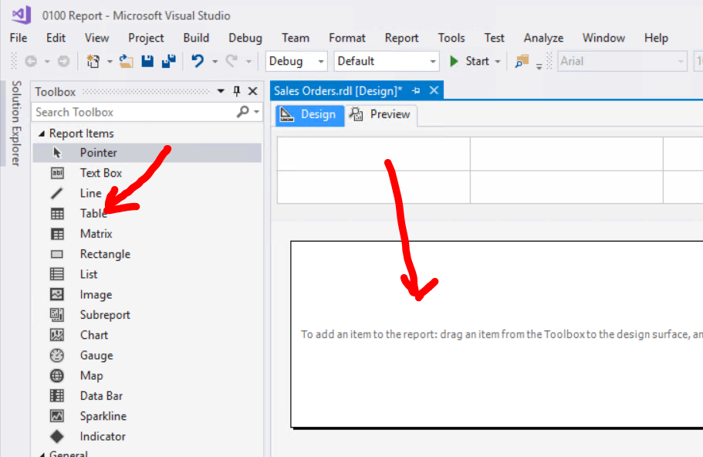

Dataset Properties / User a dataset embedded / Data Source / Query Designer…

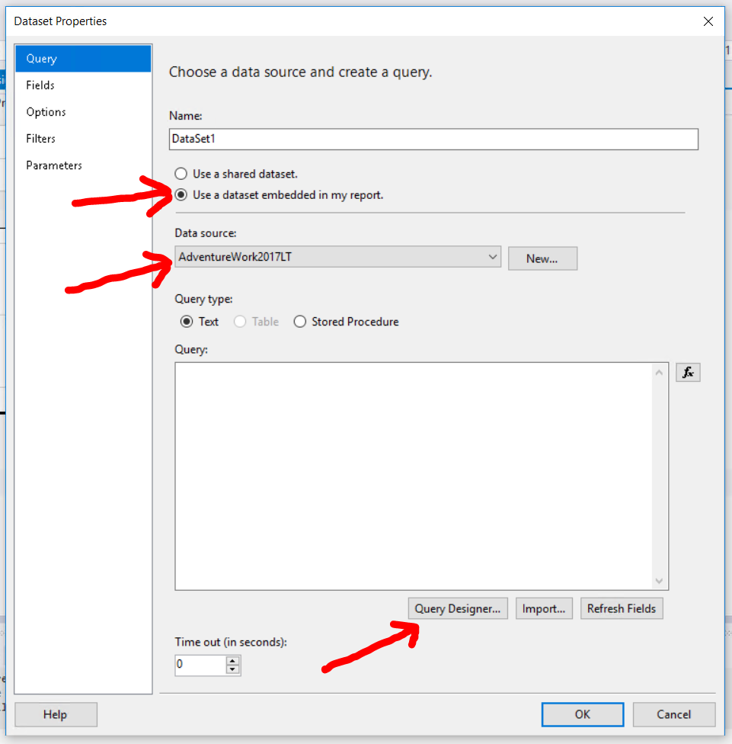

We want to make this query using query Designer

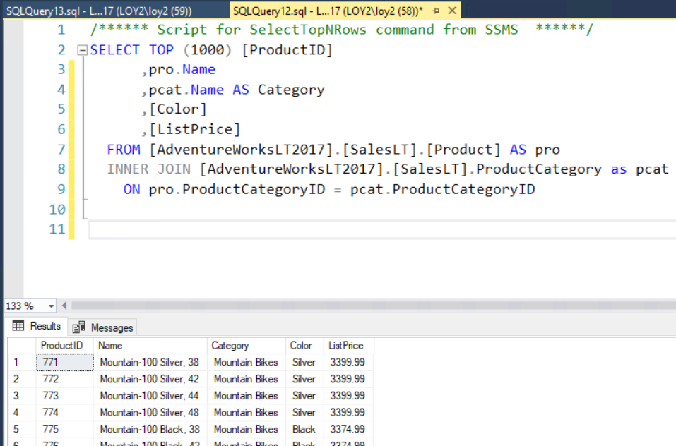

Click icon “add table” / add Product , ProductCategory

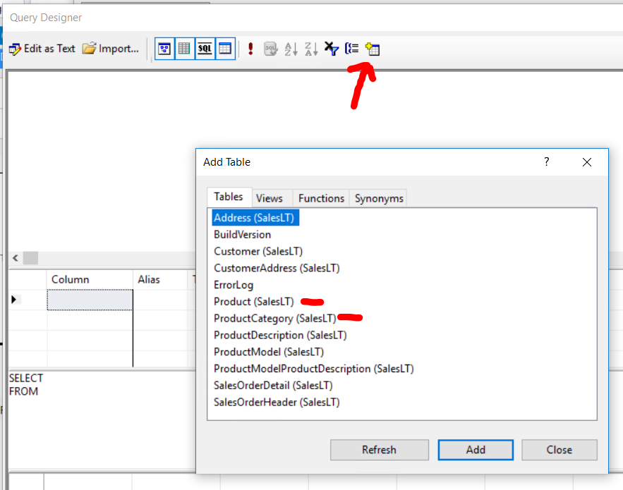

Select column ProductID, Name, Color, ListPrice table from product

Select column Name from table ProductCategory

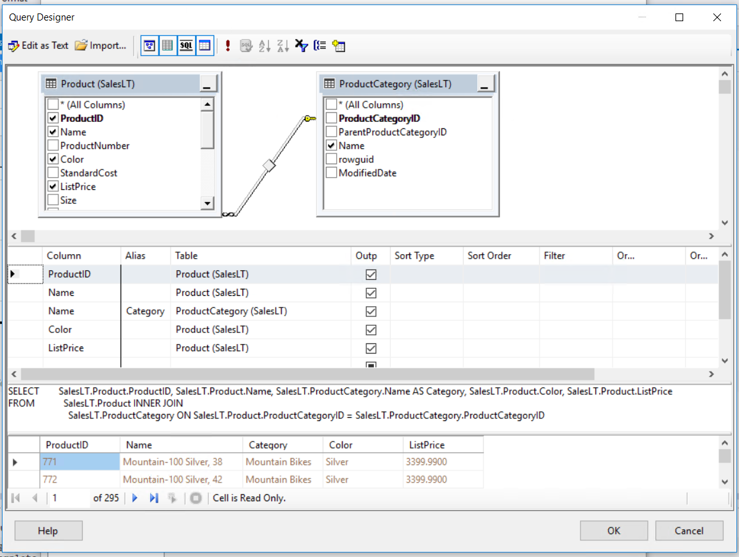

Click OK and you will have Query like so

<https://github.com/laploy/SSMS2017/blob/master/0100%20Create%20first%20report.sql>

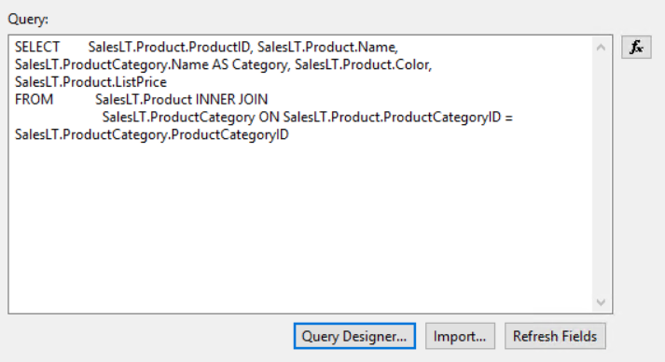

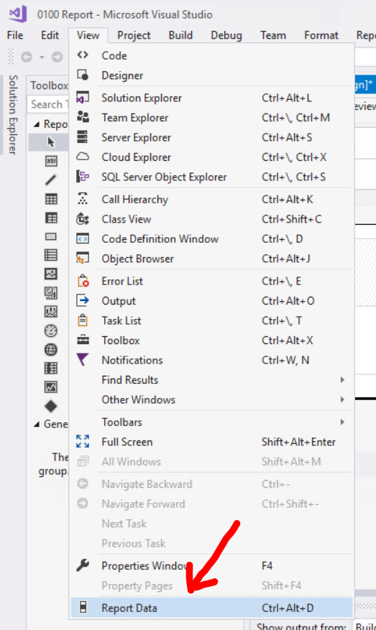

Click View / Report Data

Look in Datasets, you should see “DataSet1” with all selected column

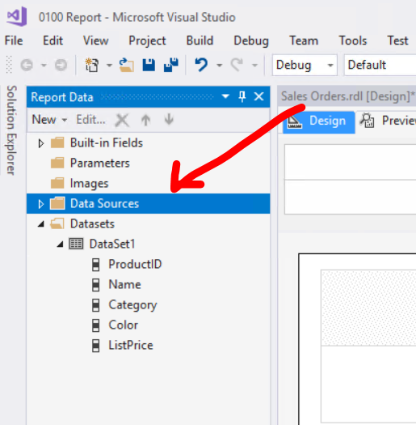

# Adding a Table to the Report

Drag column ProductID and drop into Design

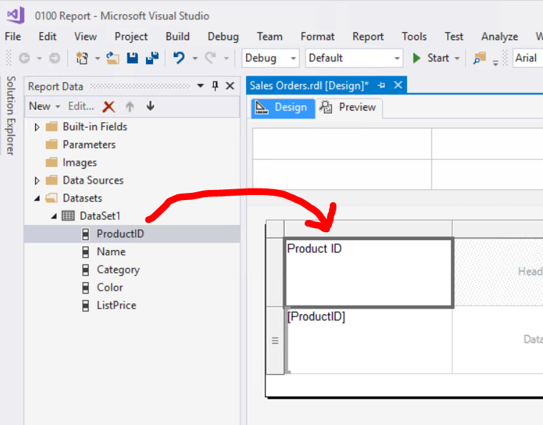

* Add all column to the design
* Adjust height
* Adjust width

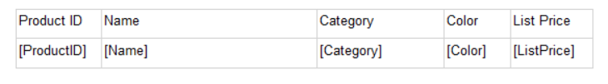

Save and preview

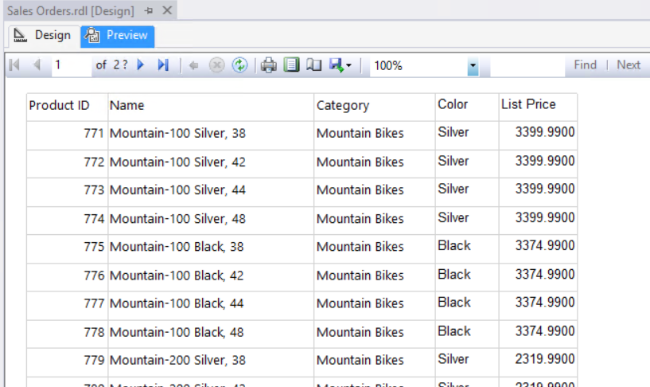

* Insert “Report Name”
* Change header background color property
* Increase header font size
* 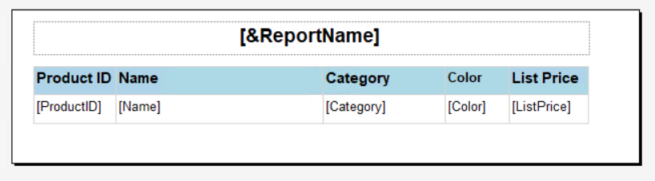Set header font bold

